WordNet

WordNet is a semantic lexicon for the English language that computational linguists and cognitive scientists use extensively. For example, WordNet was a key component in IBM’s Jeopardy-playing Watson computer system. WordNet groups words into sets of synonyms called synsets. For example, { AND circuit, AND gate } is a synset that represent a logical gate that fires only when all of its inputs fire. WordNet also describes semantic relationships between synsets. One such relationship is the is-a relationship, which connects a hyponym (more specific synset) to a hypernym (more general synset). For example, the synset { gate, logic gate } is a hypernym of { AND circuit, AND gate } because an AND gate is a kind of logic gate.

Problem Statement
This project works on building the word net graph. This has two main components.
- The synsets
- The hypernyms
The synsets are the collections of nouns that are synonyms and The hypernym has the hypernym relation of the different synsets

In this program following functionalities were implemented:
- Is there a way to connect one item to another by following the connections?
- How many other items are connected to a given item?
- What is the shortest chain of connections between this item and this other item?

Related Concepts:
1. Linked list
2. (BFS) - Breadth First Search
3. Graph Theory - Directed Graph

BFS stands for Breadth First Search is a vertex based technique for finding a shortest path in graph. It uses a Queue data structure which follows first in first out. In BFS, one vertex is selected at a time when it is visited and marked then its adjacent are visited and stored in the queue.

Graph theory, a major branch of mathematics, has been studied intensively for hundreds of years. Many important and useful properties of graphs have been discovered, many important algorithms have been developed, and many difficult problems are still actively being studied. In this course, we introduce a variety of fundamental graph algorithms that are important in diverse applications.

API:

SAP.java:
This class takes a graph as the graph parameter to its constructor. This class mainly consists of two methods.

Length
Length method is used to find the length between two vertices ‘v’ and ‘w’ in the graph. It uses BreadthFirstDirectedPaths to find the distance from each vertex and then calculates the smallest length and returns it.
This method returns -1 if there is no such path between the vertices.
Time complexity :O(n)

Ancestor
This method takes two vertices ‘v’ and ‘w’ as the parameters and finds the shortest ancestor between two vertices from the given graph.
This method returns -1 if there is no such path between the vertices.
Time complexity: O(n * v.length()* w.length()).

Wordnet.java:
In this class the constructor takes two input files as the parameters. I.e. synset.txt, hypernyms.txt.
This method uses hashmap to save the synsets, Digraph and SAP.

The methods in this class are:
Nouns
This method returns all the synset values i.e. nouns that are present in the hashmap.
Time complexity : O(n)

isNoun
This method checks whether the given noun is present in the hashmap or not. Returns true if it is present and it returns false if it is not present.
Time complexity : O(n)

Distance
This method take two nouns as the parameters and find the distance between the,.
Finally it returns the distance between the two given inputs.
Time complexity : O(n)

Sap
This method takes two nouns i.e. nounA and nounB as the parameters..
This method returns the common ancestor between the given two inputs.

Outcast:
In this class the constructor takes the wordnet object as the parameter.

Public String outcast(String[] nouns)
{
}
time complexity: O(nouns.length ^ 2).
This method takes an array of nouns as the input and returns the outcast.

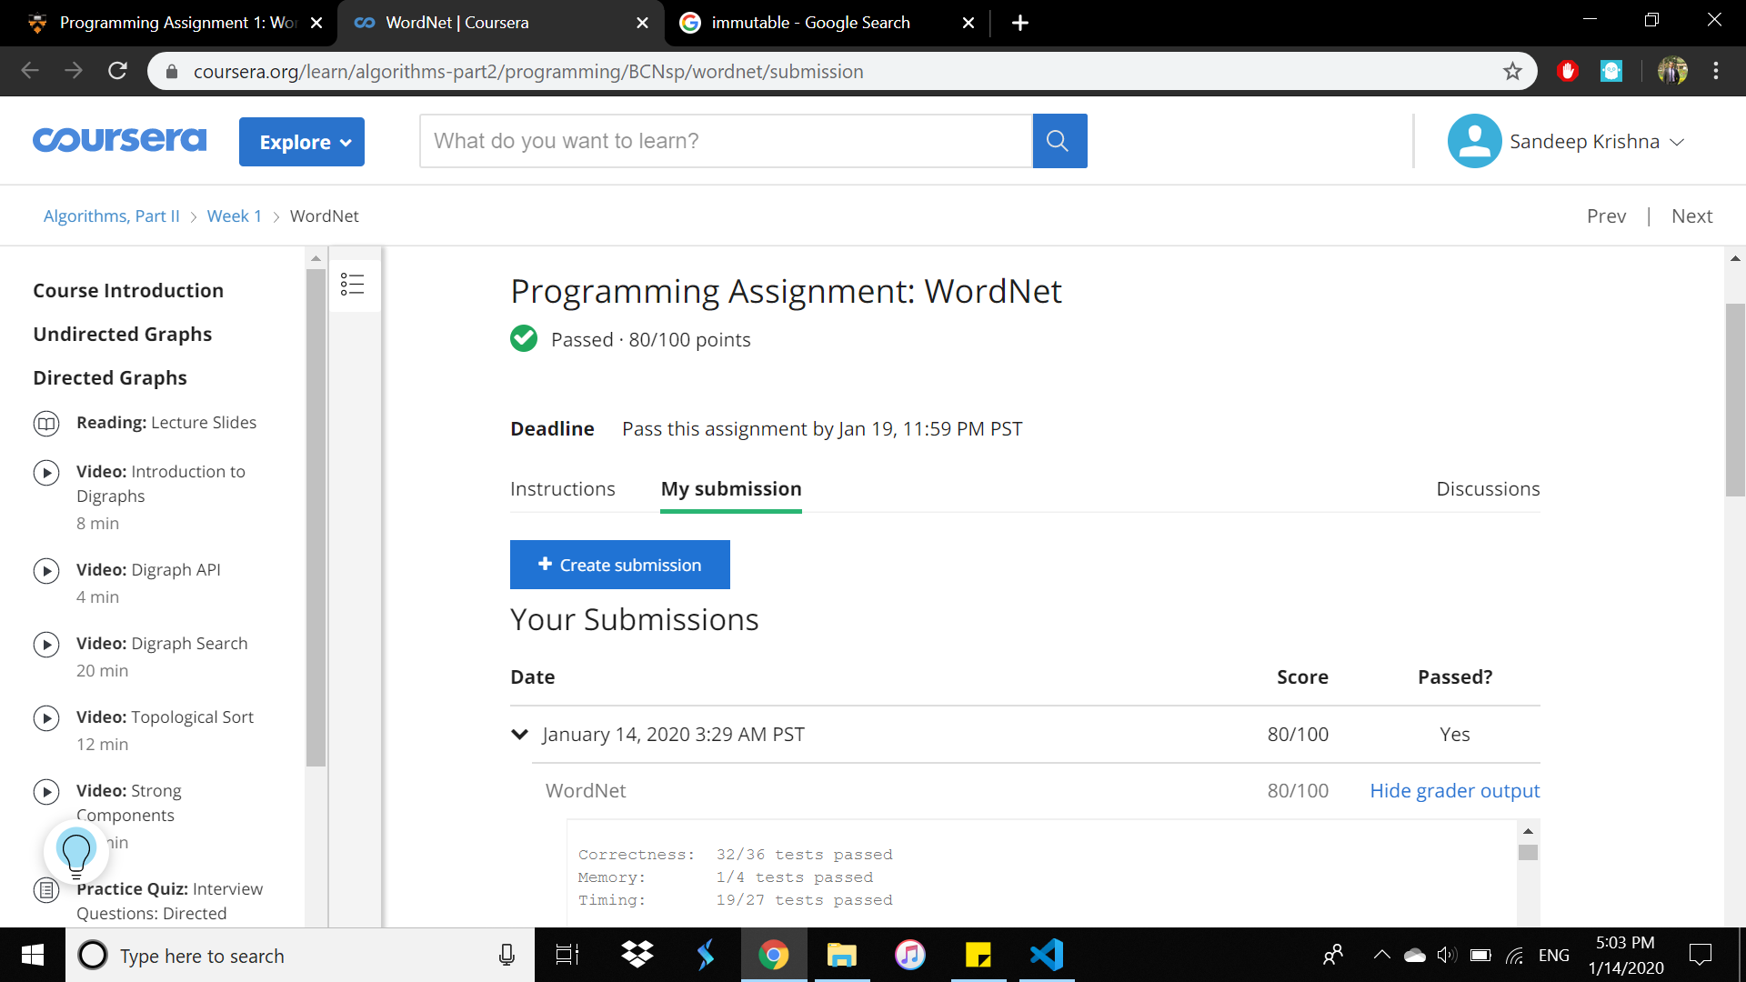

2019501035
Sandeep Krishna.

